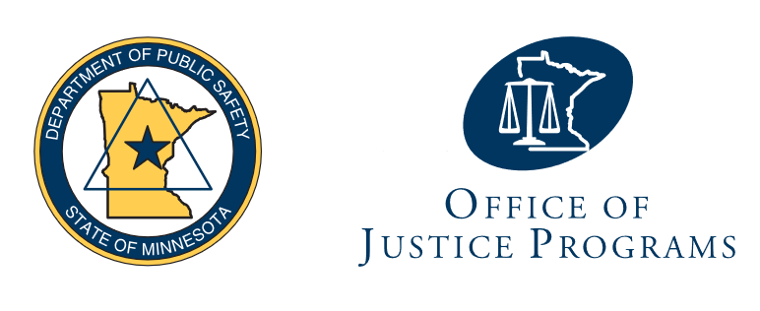

Agenda: Task Force on Improving Responses to Domestic Violence Crimes
Date: 09/22/2026, noon to 2 p.m.
Location: Microsoft Teams
Meeting ID: 297 224 904 206 37
Passcode: LJ3uo2xr

Call to order and roll call

Action: Approve agenda

Discussion: Introductions

Action: Election of chair and vice chair

Discussion: Task force charge

Discussion: Open meeting law overview

Action: Establish meeting dates

Adjournment

